

Minor Project Report on:

Accident Detection and Alert
System Using Arduino

Submitted By:
Daminot Kharduit (20BtechIT35)
Banteilang Lyngdoh Mawphlang (21BtechLIT05)
Eleazer Jeremiah Roy Langstieh (20BtechIT17)
Kevin John Kharsati (20BtechIT30)

In partial fulfillment of requirements for the award of degree in
Bachelor of Technology in Information Technology
(2023-24)

Under the Supervision of

Asso.Prof Amitabha Nath



Department of Information Technology
NORTH-EASTERN HILL UNIVERSITY
UMSHING, SHILLONG – 793 022.

Date:

To whom it may concern

This is to certify that (Daminot Kharduit (20BtechIT35),Banteilang Lyngdoh
Mawphlang(21BtechLIT05),Eleazer Jeremiah Roy Langstieh (20BtechIT17),
Kevin John Kharsati (20BtechIT30)) worked in the project Accident Detection And Alert System Using Arduino from----August------- to---December-------- 2023 and has successfully completed the minor project, in order to partial fulfillment of the requirements for the award of the degree of Bachelor of Technology in Information Technology under supervision of

Asso.Prof.Amitabha Nath
Department of Information Technology
North Eastern Hill University
Umshing Shillong-793022

 Phone No.: +91 364-2723611
Mobile No: +91 9436337792
Department of Information Technology Email: hodit@nehu.ac.in
NORTH-EASTERN HILL UNIVERSITY
UMSHING, SHILLONG – 793 022.

No: Date:

To whom it may concern

This is to certify that (Daminot Kharduit (20BtechIT35),Banteilang Lyngdoh
Mawphlang(21BtechLIT05),Eleazer Jeremiah Roy Langstieh (20BtechIT17),
Kevin John Kharsati (20BtechIT30)worked in the project Accident detection and alert system from-----August------ to---December-------- 2023 and has successfully completed the minor project, in order to partial fulfillment of the requirements for the award of the degree of Bachelor of Technology in Information Technology

External Examiner Head
Department of Information Technology
North Eastern Hill University
Umshing Shillong-793022

Department of Information Technology
NORTH-EASTERN HILL UNIVERSITY
UMSHING, SHILLONG – 793 022.

ACKNOWLEDGEMENT

It is our great pleasure to thank every individual who have given us their kind support and help. Their generosity has greatly encouraged us to finish this project. We would like to express our special thanks to GUIDE Communication who guided us throughout the project tenure. He provided us with numerous resources and technical help without which it was impossible to complete this project. We would also like to thank other faculties of the Department for supporting us during our whole project work.

` ABSTRACT
The "Accident Detection System using Arduino" is a cutting-edge solution designed to enhance road safety by swiftly detecting and responding to vehicular accidents. The system employs a combination of sensors and microcontroller technology to detect sudden changes in vehicle acceleration, indicative of a potential accident. The core components of the system include an Arduino microcontroller, an accelerometer, and a GPS module. The accelerometer is responsible for monitoring changes in acceleration, while the GPS module provides real-time location data. In the event of a sudden acceleration change beyond predefined thresholds, the system interprets this as a potential accident.
Upon detection of a possible accident, the system triggers a series of automated responses. These responses may include the activation of emergency lights, sounding of alarms, and immediate communication with emergency services. Additionally, the system utilizes the GPS data to transmit the accident location, enabling rapid emergency response and assistance.

Declaration
This is to certify that we have properly cited any material taken from other sources and have obtained permission for any copyrighted material including this report. We take full responsibility for any code submitted as part of this project and the contents of this report.

Daminot Kharduit (20BtechIT35)

Eleazer Jeremiah Roy Langstieh (20BtechIT30)

Kevin John Kharsati (20BtechIT30)

Banteilang Lyngdoh Mawphlang (20BtechIT05)

Certificate
This is to certify that Daminot Kharduit (20BtechIT35), Eleazer Jeremiah Roy Langstieh (20BtechIT17), Kevin John Kharsati (20BtechIT30), and Banteilang L Mawphlang (21BtechLIT05) worked in the project House Service Provider from September to December 2023 and has successfully completed the minor project, in order to partial fulfillment of the requirements for the award of the degree of Bachelor of Technology in Information Technology under my supervision and guidance.

Asso.Prof Amitabha Nath

Department of Information Technology
North-Eastern Hill University
Shillong-793022, Meghalaya, India

Certificate
This is to certify that Daminot Kharduit (20BtechIT35), Eleazer Jeremiah Roy Langstieh (20BtechIT17), Kevin John Kharsati (20BtechIT30), and Banteilang L Mawphlang (21BtechLIT05) worked in the project House Service Provider from September to December 2023 and has successfully completed the minor project, in order to partial fulfillment of the requirements for the award of the degree of Bachelor of Technology in Information Technology under my supervision and guidance.

External Examiner Head

Department of Information Technology
North-Eastern Hill University
Shillong-793022, Meghalaya, India

List of Contents
- Introduction
- Overview
- Problem statement
- Scope of the project
- Objectives

- Existing System
- Organization of Report
- Literature Survey
- Previous work on Internet of vehicles
- Previous work on Accident Detection System
- Proposed Solution and Strategy
- System Requirement and specification
    - Functional requirement
    - Non Functional requirement
  - Safety requirement
  - Performance requirement
  - Security requirement
  - Software quality attribute
- Hardware requirement
- Working of:
- Arduino uno
- Accelerometer
- GSM Module
- GPS Module
- LCD
- Proximity Sensor
- Buzzer
- Software requirement
- System analysis and design
- System architecture
- Flow chart
- Block Diagram
- Use Case Diagram
- Sequence Diagram
- Testing
- Testing of GPS Module
- Testing of GSM Module
- Testing of Accelerometer sensor
- Testing of LCD Display
- Testing of Buzzer
- Testing of Proximity Sensor
- System Testing
- Implementation
- Algorithm
- Result
- Conclusion
- Limitations
- Future Scope
- Acknowledgement
- References

Chapter-1
Introduction
Overview
Road accidents continue to be a major cause of fatalities and injuries worldwide. The World Health Organization (WHO) estimates that approximately 1.35 million people die each year due to road traffic accidents, with an additional 20 to 50 million suffering non-fatal injuries. The immediate aftermath of an accident is crucial for providing medical assistance, clearing road obstructions, and ensuring the safety of those involved. The Accident Detection System (ADS) is a technological solution designed to enhance road safety by providing real-time monitoring and rapid response in the event of a road accident. Traffic accidents are a significant global concern, leading to loss of lives, injuries, and property damage. The timely detection and reporting of accidents can significantly reduce emergency response times and improve the overall efficiency of accident management systems.
Internet of Vehicles (IoV): Concept and Definition: The Internet of Vehicles is a network that interconnects pedestrians, cars, and parts of urban infrastructure. It uses various sensors, software, in-built hardware, and types of connection to enable reliable and continuous communication. As a part of a smart city, IoV strives to make transportation more autonomous, safe, fast, and efficient, reducing resource waste and detrimental impacts on the environment.
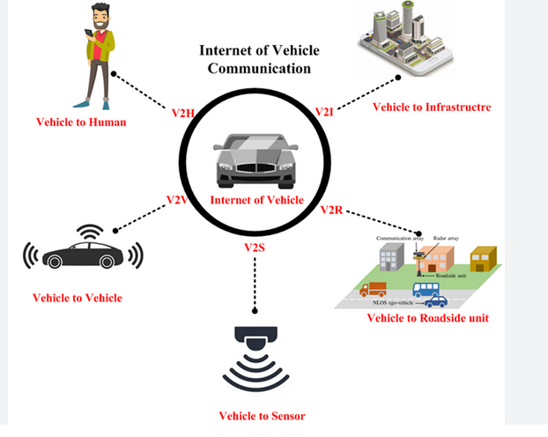
Problem Statement
Automatic Vehicle Accident Detection and Alert System using Arduino Uno along with GPS and GSM Module is implemented to prevent road accident and allow the medical or rescue team to reach the accident site on Time.
Scope of the Project
- The scope of the project is to design and implement a system that will be able to detect and prevent an accident and send the location information to emergency services.
- The system will be implemented using Arduino Uno as the controlling unit
- The Accelerometer sensor will be used to detect an accident.
- The GPS module will track the location of the accident.
- GSM module is then used to transmit the location information to the emergency services
Objectives
The Main objective of this system is to detect and prevent accident and when accident is detected it will send a notification to emergency services. This system will detect the occurrence of an accident without any user input since it employs a sensor for detecting the accident. When the accident occurs, it will provide the exact location of the vehicle by latitude and longitude coordinates to the emergency contact set by the user.
Existing System
Manual incident detection methods detect the accident from the motorist report, transportation department or public crews report, aerial surveillance or close circuit camera surveillance. The drawback of this type of detection system is that someone has to witness the incident. Moreover, there are delays and inaccuracies due to the expression problem of the witness. Compared to this detection method, driver initiated incident detection system has more advantages which includes the quick reaction, more incident information etc. However, with the severity of the accident, driver may not be able to report at all
Organization of the report
Chapter 2 deals with the Literature Survey. The System Requirements Specification are briefly discussed in Chapter 3. Chapter 4 deals with system analysis and design containing the architecture, block diagram and various UML Diagrams of the system. Chapter 5 deals with Testing and Chapter 6 with Implementation. Chapter 7 contains the Result and Discussion and Chapter 8 contains the Conclusion

Chapter-2
Literature Survey
Previous Work on Internet of Vehicles:
Research on the Internet of Vehicles (IoV) involves the integration of vehicles with the internet, enabling communication between vehicles, infrastructure, and other entities to enhance transportation efficiency, safety, and services. Below is a brief overview of some previous work and key themes in the IoV domain:
- Vehicular Communication Technologies:
  - Work: Numerous studies have explored communication technologies for IoV, including Dedicated Short Range Communications (DSRC), Cellular Vehicle-to-Everything (C-V2X), and ad-hoc networking.
  - Key Themes: Evaluating the performance, reliability, and security of communication technologies in real-world IoV scenarios.
- Traffic Management and Optimization:
  - Work: Research has focused on developing intelligent traffic management systems using IoV data. This includes traffic flow optimization, congestion prediction, and adaptive traffic signal control.
  - Key Themes: Utilizing real-time data from vehicles to improve overall traffic management and reduce congestion
Previous work on Accident detection system:
Accident detection systems have been a subject of extensive research and development with a focus on improving road safety and emergency response. Below is an overview of some key themes and previous work in the area of accident detection systems:
- Sensor Technologies:
  - Work: Researchers have explored various sensor technologies, including accelerometers, gyroscopes, and collision sensors, for accurate detection of vehicle collisions.
  - Key Themes: Investigating the reliability, sensitivity, and accuracy of different sensor technologies in identifying accidents.
- Machine Learning and Pattern Recognition:
  - Work: Utilizing machine learning algorithms and pattern recognition techniques to analyze sensor data and identify patterns associated with accidents.
  - Key Themes: Developing intelligent algorithms that can distinguish between normal driving events and potential accidents.
- Communication Technologies:
  - Work: Integrating accident detection systems with communication technologies such as cellular networks or dedicated short-range communication (DSRC) for real-time reporting of accidents.
  - Key Themes: Enabling prompt communication of accident information to emergency services and other connected vehicles.

Proposed Solution:

Components:
- Arduino Microcontroller:
  - Serves as the central processing unit for data acquisition and decision-making.
- Accelerometer:
  - Measures changes in acceleration to detect sudden impacts or collisions.
- GPS Module:
  - Provides real-time location data for accurate incident mapping.
- GSM/GPRS Module:
  - Enables communication with emergency services by sending accident alerts.
- Power Supply:
  - Battery or vehicle power source to ensure continuous operation.

Strategy:
- Data Acquisition:
  - The accelerometer continuously monitors the vehicle's acceleration.
  - GPS module captures real-time location information.
- Threshold Detection:
  - Define thresholds for acceleration changes that indicate a potential accident.
  - If the detected acceleration exceeds the predefined threshold, it triggers the accident detection process.
- Decision Algorithm:
  - Implement an algorithm on the Arduino to analyze accelerometer data.
  - The algorithm evaluates the magnitude, duration, and pattern of acceleration changes to determine if it corresponds to an accident.
- Location Mapping:
  - Utilize GPS data to include precise location information in the accident alert.
  - Map the coordinates to a physical location for emergency response.
- Emergency Alert System:
  - Activate the GSM/GPRS module to send an immediate alert to predefined emergency contacts or services.
  - Include information such as the vehicle's location, time of the incident, and any available contextual data.
- Alarm and Indication:
  - Trigger visual and audible alarms within the vehicle to alert occupants about the incident.
  - Include indicators on the Arduino board to display the system's status.
- Communication with Emergency Services:
  - Establish a communication protocol to relay accident details to emergency services.
  - Send an SMS or make a call to emergency services, providing them with essential information.
- Post-Incident Actions:
  - Implement a mechanism to disable or reset the accident detection system after an incident.
  - Log incident data for post-analysis and reporting.
- Power Management:
  - Implement power-saving features to ensure efficient use of the power source.
  - Include low-power modes when the system is not actively detecting incidents.
- Testing and Validation:
  - Conduct rigorous testing of the system under various conditions, including simulated and real-world scenarios.
  - Validate the accuracy of the accident detection algorithm.
- User Interface:
  - Develop a user-friendly interface to configure system settings, view incident logs, and perform diagnostics.
  - Consider integrating a display or indicators for real-time feedback to users.

Chapter-3
System Requirements and Specification
It describes about the requirements. It specifies he hardware and software requirements that are in order to run the system properly. The Hardware Requirement Specification is explained in detail, which includes the overview of functional and non-functional requirements.
Functional Requirement
Functional Requirements defines the function of the system and gives the outline of what the system does.
- The system shall detect an accident based on the magnitude set in the code
- The system shall trigger an alarm upon detecting an accident.
- The system shall continuously
monitor accelerometer data.
- When an accident occurs, GPS data is collected from the GPS Module in the form of latitude and longitude.
- The location of the crashed vehicle is then sent to the mobile of the emergency service through the GSM Module in the form of an SMS.

Non-functional Requirements
Non-functional requirements are the requirements which are not directly concerned with the specific function delivered by the system.
1)Performance Requirements
• The system should not take a long time to send the message after the accident has been detected.
• The GPS module should be connected to a number of satellites to obtain accurate location information
2) Safety Requirements
• The system should be kept at a place in the car where it will be safe from physical damage during an accident

3) Security Requirements
• The system should not send the location information to any other except the concerned emergency contact
4) Software Quality Attributes
• The cellular network should be available at the location of the accident so that the message to the emergency service can be sent. • The geographical location of the crashed vehicle should be correct so that the emergency responders will reach the exact location.
• The system should maintain the constant flow of information from the accelerometer and analyze them accordingly.
• The system should save a maximum number of users lives
Hardware Requirements
- Arduino Uno
- GPS module
- GSM module
- Accelerometer
- Power Supply
- Connecting Wires
- Breadboard
- Buzzer
- Proximity Sensor

Working of Arduino Uno
The Arduino UNO is a widely used open-source microcontroller board based on the ATmega328P microcontroller. The Arduino is the control unit to detect or alert when an accident occurs. It collects the data from the Accelerometer sensor and GPS module and reflects the output either in display system or through a message. The Accelerometer sensor will detect coordinates of the vehicle position which acts as an accident detection module. It sends the message to the receiver though GSM module and display the message on LCD.
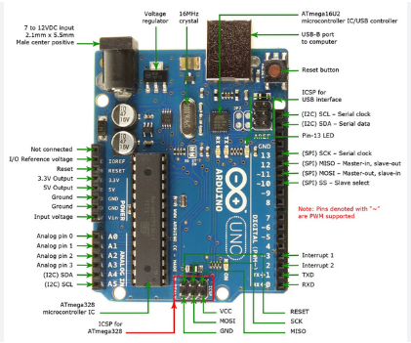
Diagram of Arduino

Working of Accelerometer Sensor
The Accelerometer is a sensor to detect the coordinates of vehicle position. The information is sent to the Arduino where it will determine whether the vehicle has crashed or not
t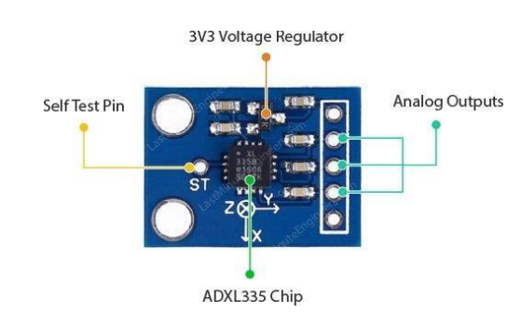
Diagram of Accelerometer

Working of GSM Module(SIM900 A)
For providing communication between the system and the allocated mobile number, GSM SIM900A module is preferred. The name SIM900 says that, it is a tri band work ranging a frequency of 900MHz to 1900 MHz .Receiving pin of GSM module and transmitting pin of GPS module are used for communication between the modules and the mobile phone.
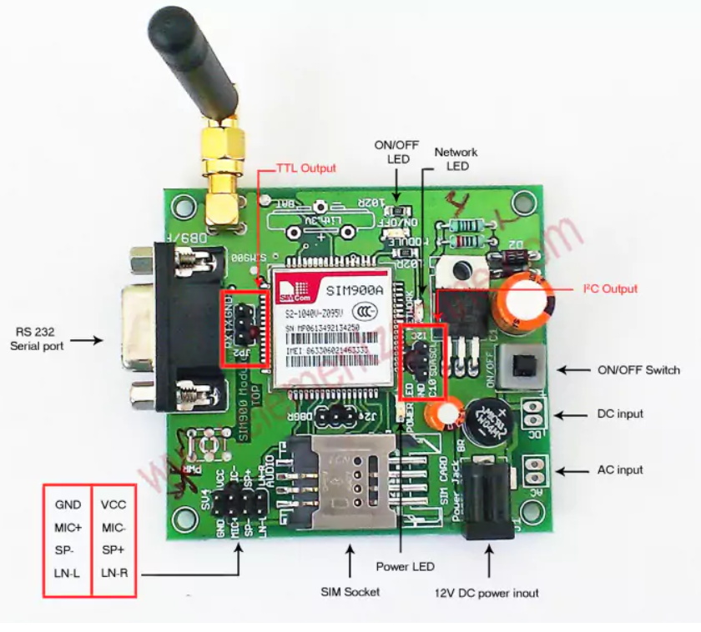
Diagram Of GSM module

Working of GPS Module
To find the location on the earth the whole is divided into some coordinates where the location can be easily captured by a module called GPS module .This GPS module will find the location of the vehicle and the information fetched by the GPS receiver is received through the coordinates and the received data is first send to Arduino and the information is transmitted to the saved contact through GSM module
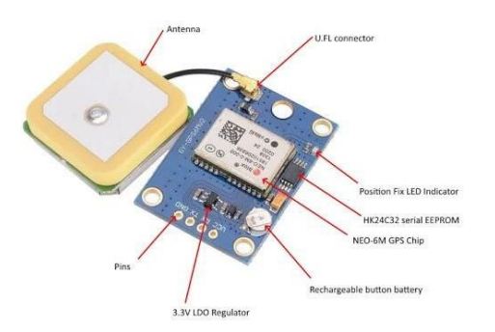
Diagram Of GPS module
Working Of LCD
LCD (Liquid Crystal Display) is used to convey critical information to vehicle occupants when an accident is detected. The system collects data from various sensors, processes it to determine an accident, and triggers alerts. The LCD displays messages, safety instructions, and emergency contact numbers to inform and guide occupants during and after an accident.
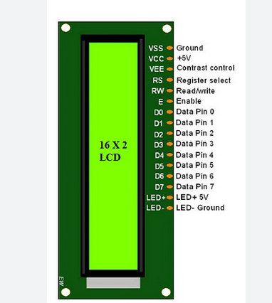
Diagram Of LCD

Working of Proximity Sensor
Proximity sensors detect nearby objects by emitting signals and measuring the time it takes for them to bounce back. If an object is too close, indicating a potential collision, the accident detection system is alerted to take appropriate actions to prevent an accident.
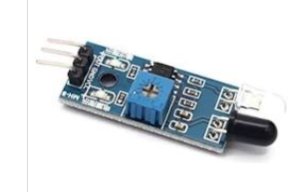
Diagram Of Proximity Sensor

Working of Buzzer
The buzzer is activated when a potential accident or collision is detected. It emits a loud sound to immediately alert vehicle occupants and others about the critical situation, prompting quick and appropriate responses to enhance safety

Diagram Of Buzzer

Software Requirements
• Windows 10 Operating System
•Arduino IDE
Arduino IDE
The Arduino Integrated Development Environment - or Arduino Software (IDE) - contains a text editor for writing code, a message area, a text console, a toolbar with buttons for common functions and a series of menus. It connects to the Arduino hardware to upload programs and communicate with them

Chapter - 4
System Analysis And Design
System Architecture
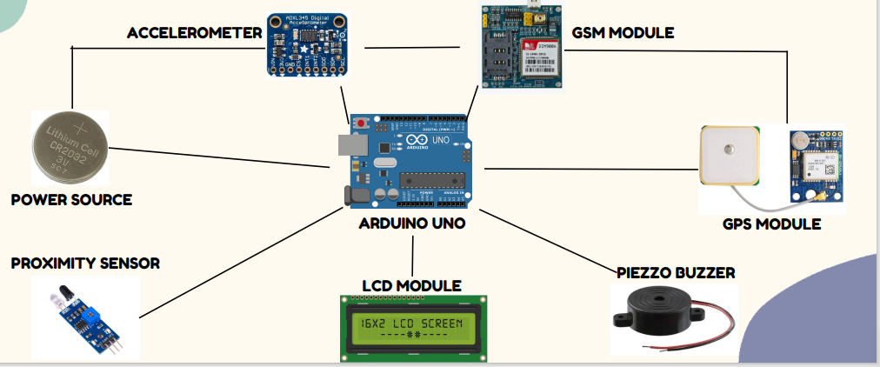
Architecture of Accident Detection System Using Arduino

In this architecture when an accident occurs it is detected by the accelerometer sensor, and if the accident is serious it sent location information to emergency service through GSM module and display location in google map using GPS Module and when an obstacle is nearby it is detected by the proximity sensor and the buzzer will make a sound when obstacle is detected. And the LCD is used for displaying accident information.

Block Diagram

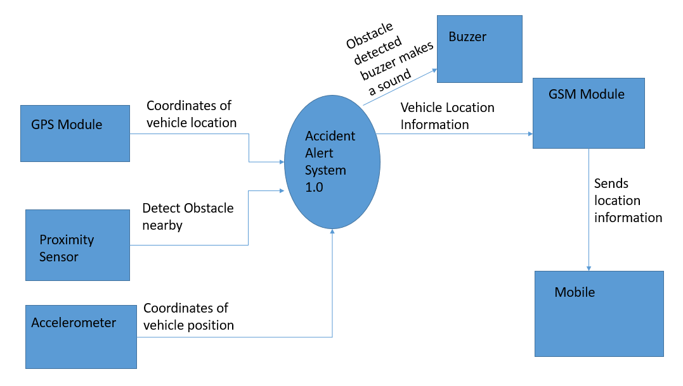

Flow Chart

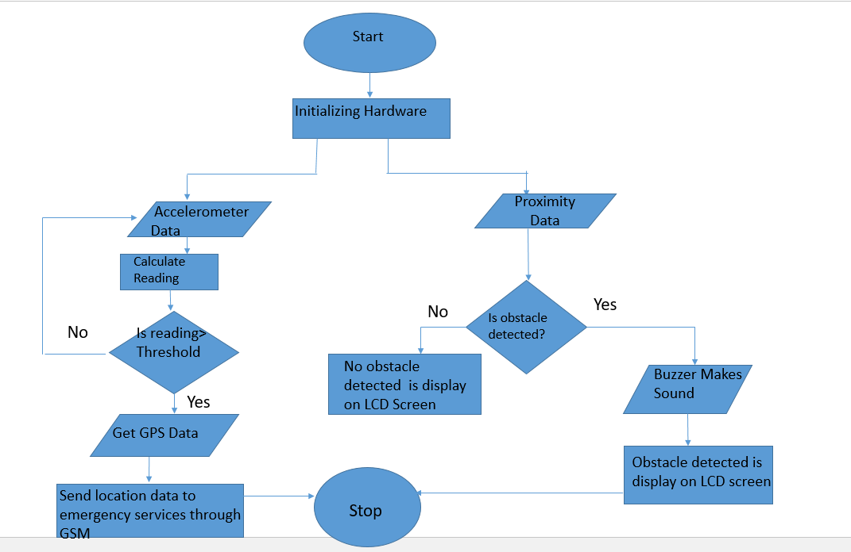

Use Case Diagram

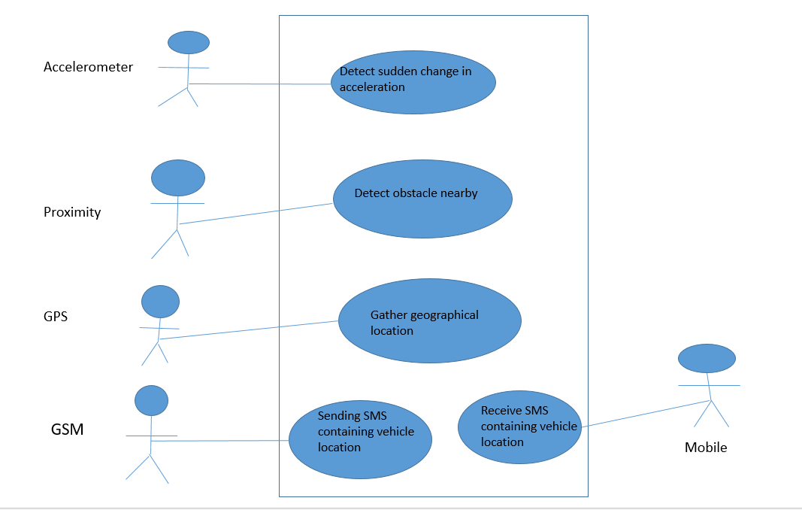

Sequence Diagram

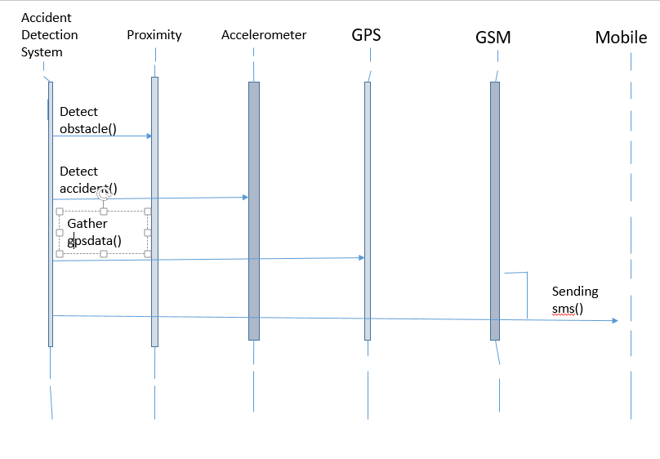

Chapter - 5

Testing
Testing of GPS Module
GPS module has to be tested to check if it is able to accurately provide the current location. GPS receivers gather data by communicating with a number of satellites at the same time. They are pre-programmed to know where the GPS satellites are at any given time.The satellites transmit information about their position and the current time in the form of radio signals towards the Earth. These signals identify the satellites and tell the receiver where they are located. It indicates the position fix, it will blink at various rates depending on what state it is in. No Blinking indicates that it is searching for the satellites. If it blinks every second which indicates that the position is found.
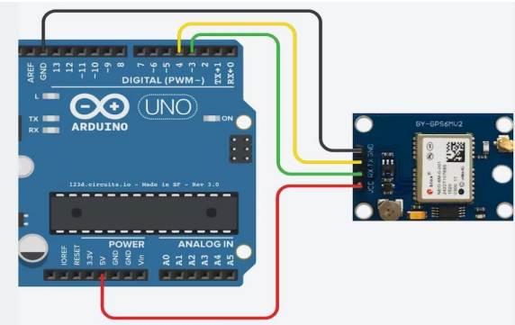
Connection of ARDUINO and GPS
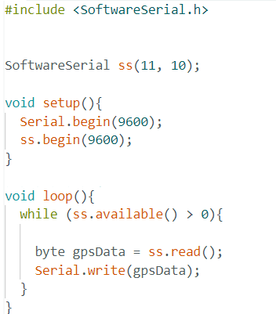
Testing of GPS Module

Testing Of GSM Module
We need to ensure that the connection is established between Arduino and GSM. We can do this by connecting TX pin of GSM to RX pin of Arduino and RX pin of GSM module to TX pin of Arduino. We can also do the connection by selecting two PWM enabled pins of Arduino. It uses software serial library of Arduino, when the connection is established, the data can be fed directly to GSM
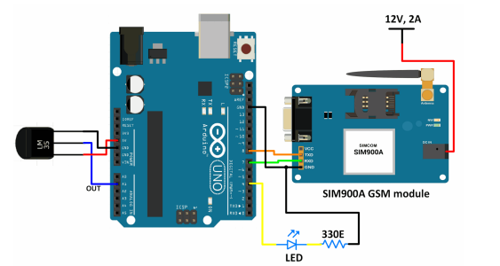
Connection of ARDUINO and GSM
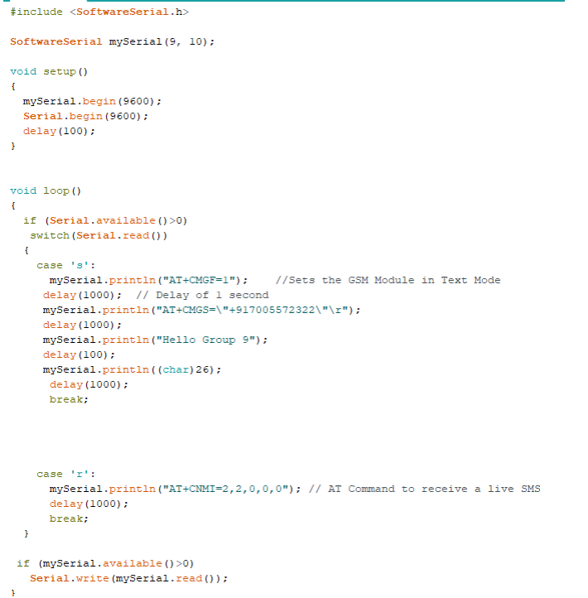Testing OF GSM

Testing of Accelerometer
We begin by mounting the accelerometer on the breadboard. Connect the VCC pin to the Arduino’s 5V pin and the GND pin to the Arduino’s Ground pin. Connect the X, Y, and Z outputs to Arduino’s analog pins A0, A1, and A2. To get accurate results, we need to change the analog reference (AREF) voltage on the Arduino. This is accomplished by connecting the Arduino’s 3.3V pin to the AREF pin.
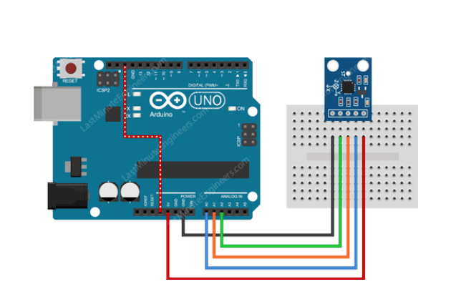
Connection of ARDUINO and Accelerometer
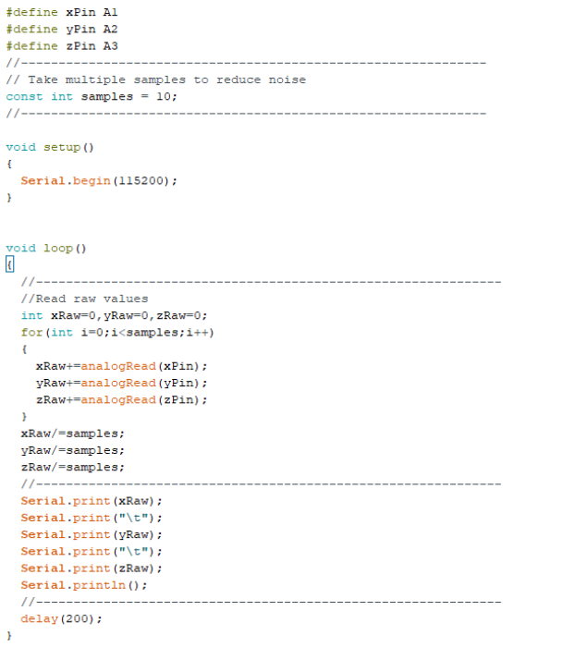
Testing of Accelerometer

Testing of LCD
The interface between LCD and Arduino was also tested. We need to place our LCD on the breadboard. We should make sure that all the connections are done according to the circuit diagram. A potentiometer was also added to the connection. All connections should be firm and tight. We power up our Arduino via USB and check whether the LCD lights up. If yes, then the LCD is working fine.
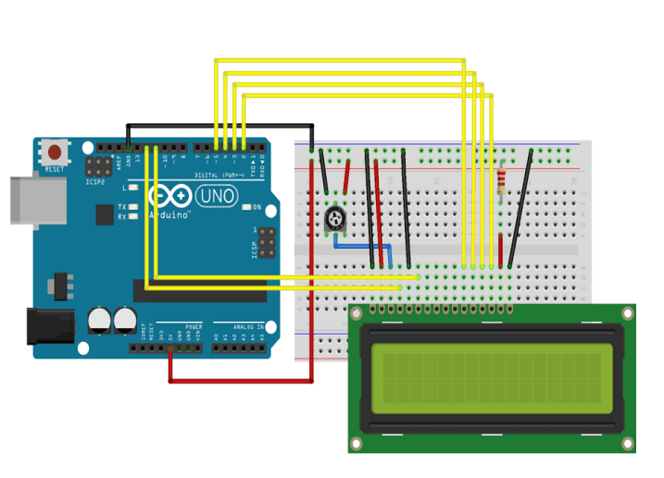
Connection of ARDUINO and LCD Display

Testing of Buzzer
A connection between the buzzer and Arduino was also tested. We connected the positive wire of buzzer to any pin of Arduino and negative wire to GND pin of Arduino.
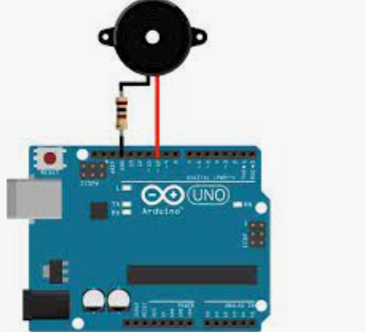
Connection between ARDUINO and Buzzer

Testing of Buzzer

Testing of Proximity Sensor
A connection between Arduino and proximity sensor is also tested. We connect the Out pin of proximity to any pin of Arduino ,VCC and GND pin of proximity sensor to ARDUINO 5V and GND pin.
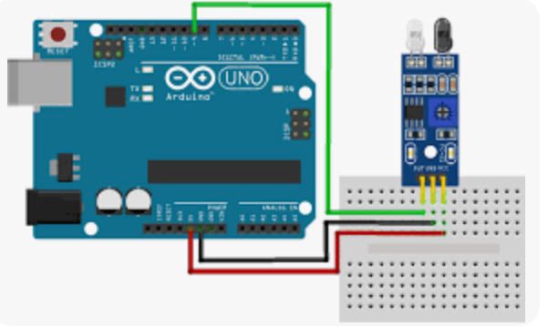
Connection Between ARDUINO and Proximity Sens

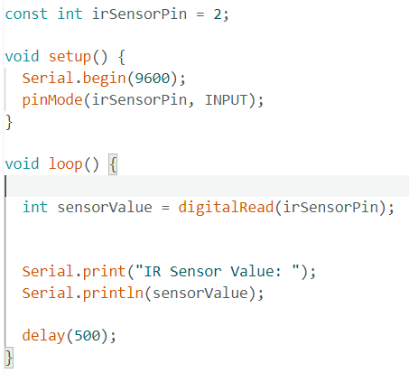
Testing Of Proximity Sensor

System Testing
After the development of the system was completed, a system test was performed to check whether the system can perform to meet all the requirements. All the different modules and sensor were integrated with the Arduino Uno using connecting wires and breadboard. A 12v power supply is used to power up the GSM Module and the Arduino Uno

Chapter - 6
Implementation
Algorithm
Step 1: Start
Step 2: Set threshold values for Proximity sensor
Step 3: Calculate Proximity sensor reading
If (obstacle is detected)
Activate Buzzer
Else
Go to Step 4

Step 4: Set threshold values for Accelerometer sensor
Step 5: Calculate Accelerometer sensor reading
If (Accelerometer value < Accelerometer threshold)
Go to Step 5
Else
Go to Step 6

Step 6: Get GPS coordinates
Step 7: Send the location information to the emergency service centre through the GSM Module
Step 8: Stop

- Arduino Uno is used as controlling unit, communicating between modules for better information transformation at time.
- Proximity sensor is used for detecting an obstacle and when obstacle is detected a buzzer is turned on
- Accelerometer detects the occurrence of accident and sends signal to the microcontroller (Arduino Uno) for further functioning.
- The GPS module provides the location of the certain place where the vehicle is in the real time
- If an accident occurs, the accelerometer detects it and location of accident is obtained using GPS, and finally sends the information to the ambulance service by the help of a GSM module
- The message obtained in mobile phone contains the location of the accident in the form of google map link which will help the emergency units like ambulance service to reach out to the victim in time and rescue lives

Chapter-7
Results
When an accident occurs the system successfully sents the alert message to given mobile number. The Accelerometer sensor, proximity sensor and other modules functioned properly and gave desired outputs. The GPS module took in accurate location data in the form of the latitude and longitude coordinates. The GSM Module also performed satisfactorily in sending the message to the receiver.
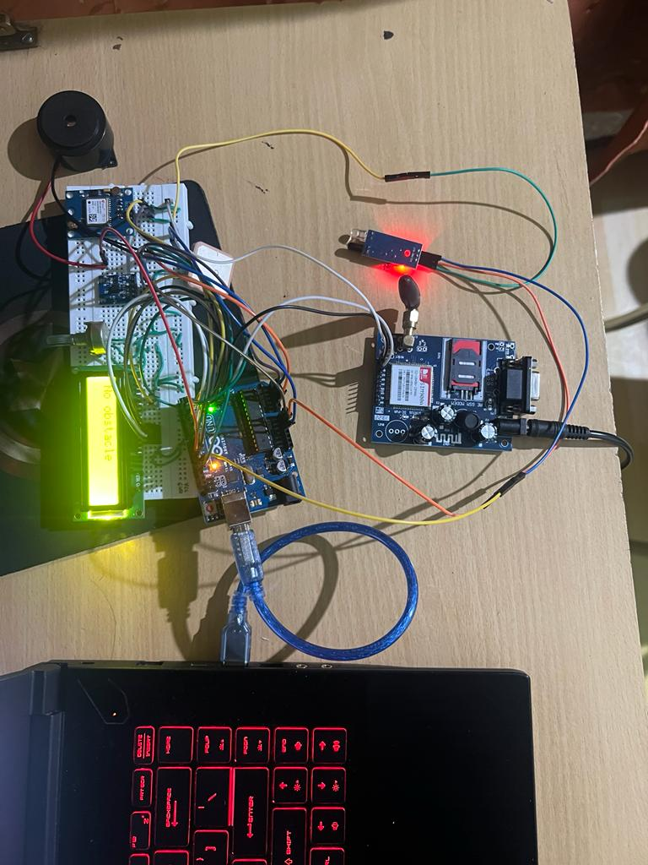Connection of ARDUINO with all other Module

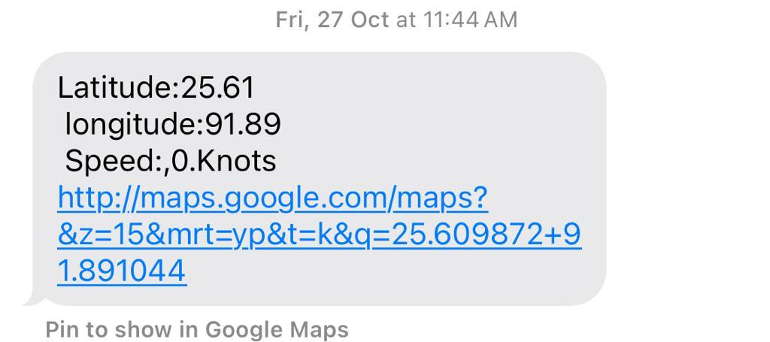
Message Received by receiver

Chapter-8
Conclusion
The Accident detection system is helpful to detect and alert when an accident occurs. It utilizes the Arduino Uno along with the GPS and GSM Module. The Accident Detection System serves as an innovative and proactive approach to improving road safety and emergency response. As technology continues to advance, there is potential for further enhancements and integration with emerging technologies to create even more robust and effective systems.
We have successfully gathered all hardware components needed to implement the system. Each hardware components were individually tested and they are found to be working as expected. The hardware components are then integrated into a single device. Coding was successfully done to implement the system. The whole complete system was then tested and successfully met all desired results. We encountered few problems while developing the system but with the help of our guide, we were able to overcome those problems.
Limitations
- Proximity sensors used in these systems often have a limited detection range. Large objects or obstacles may not be detected in time, especially at high speeds.
- The accuracy of the system heavily relies on the accuracy and reliability of the sensors used. Calibration issues or sensor malfunctions can lead to false positives or false negatives.
- External factors like strong vibrations, sudden jerks, or road irregularities can trigger false alarms, leading to unnecessary activation of the emergency system
- Integrating the system with existing vehicles may require modifications, and achieving a seamless integration with different vehicle models can be challenging.
- GSM modules used for communication have a range limitation. In remote areas with poor network coverage, the system may struggle to transmit alerts to emergency service centers.
Future Scope
The future scope of this system is to Improve accuracy and reduce false alarms , Enhance detection range and reliability, Provide intuitive displays for drivers. And Integrating V2X communication technology allows vehicles to communicate with each other and with infrastructure, sharing real-time information about road conditions, potential hazards, and accidents.

` References
- Nanda, S., Joshi, H., & Khairnar, S. (2018). An IOT Based Smart System for Accident Prevention and Detection. 2018 Fourth International Conference on Computing Communication Control Automation (ICCUBEA).
- Syedul Amin, M., Jalil, J., & Reaz, M. B. I. (2012). Accident detection and reporting system using GPSGPRS and GSM technology. 2012 International Conference on Informatics, Electronics & Vision(ICIEV). doi:10.1109/iciev.2012.6317382
- Dr. Avinash Chandra, Rishab Kaul, Shaanvi Mehta, Subharthi Saha, “Accident Alert and Vehicle Tracking System”, Vellore Institute of Technology, International Journal of Engineering Research & Technology (IJERT) Vol. 9 Issue 11, November2020.
- Dilipkumar A. Borikar and Manoj B. Chandak, “Accident Detection and Emergency Alerting System for Road Safety”, Bioscience Biotechnology Research Communications Special Issue Vol 13 No 14 (2020

